Threshold values to detect white colour stripes , then edge detection , followed by line detection using Computer Vision

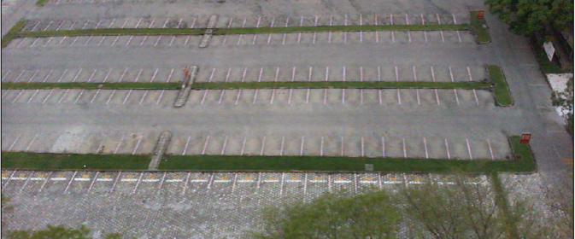 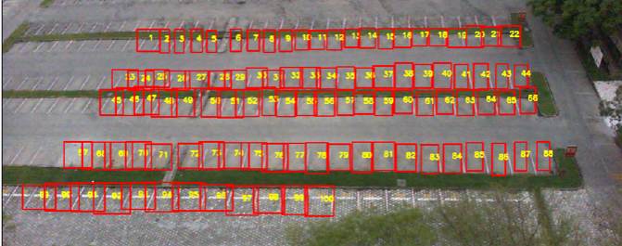

Empty Parking Lot

Red boxes drawn from pickled values containing co-ordinates of slots and Labeling the slot numbers

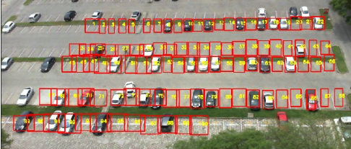

Cars in Parking Slots in Parking Lot

Detecting Parking Slot whether empty or occupied through trained CNN Model

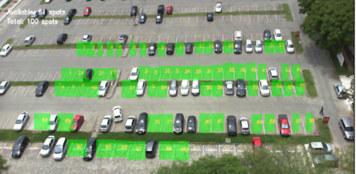 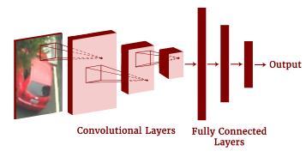

Empty parking spaces are detected with Test Accuracy of 99.28%

VGG-16 Convolutional Layers, followed by Dense layer of 512 neurons and dropout of 0.4 , finally Dense layer of 2 neurons for classifying empty or occupied parking slots

Information of how many and which Parking Slots Empty are send to the App

ANDROID

APP

ANDROID

APP

DIRECTIONS THROUGH GOOGLE MAPS TO YOUR PARKING SLOT NUMBER

ENTER DATE OF PARKING , START-TIME , END-TIME

BOOK YOUR

SLOT

LOGIN /

SIGNUP

SPLASH SCREEN OF ANDROID APP

SELECT YOUR SLOT FROM SLOT BUTTONS

END

CONFIRMATION MESSAGE SEND TO THE USER ABOUT HIS SLOT BOOKING DETAILS